# Assignment 1

Git Repo in which there are currently 3 releases running

22Q1 🡪 index.html (22Q1 Code)

22Q2 🡪 index.html (22Q2 Code)

22Q3 🡪 index.html (22Q3 Code)

Clone all the branches in JM separately like /data/project/22Q1 – 22Q2 – 22Q3, create 3 jobs 1st Job for 22Q1, 2nd for 22Q2 and 3rd Job for 22Q3.

After cloning deploy 22Q1 on slave 1, 22Q2 on Slave 2 and 22Q3 on slave 3 httpd. When the index.html file updates the same should be updated.

Jenkins Master:

Slave 1 🡪

Slave 2 🡪

Slave 3 🡪

Do this using declarative pipeline, multi-branch pipeline.

## Step 1

Created Jenkins Master and 3 Slaves

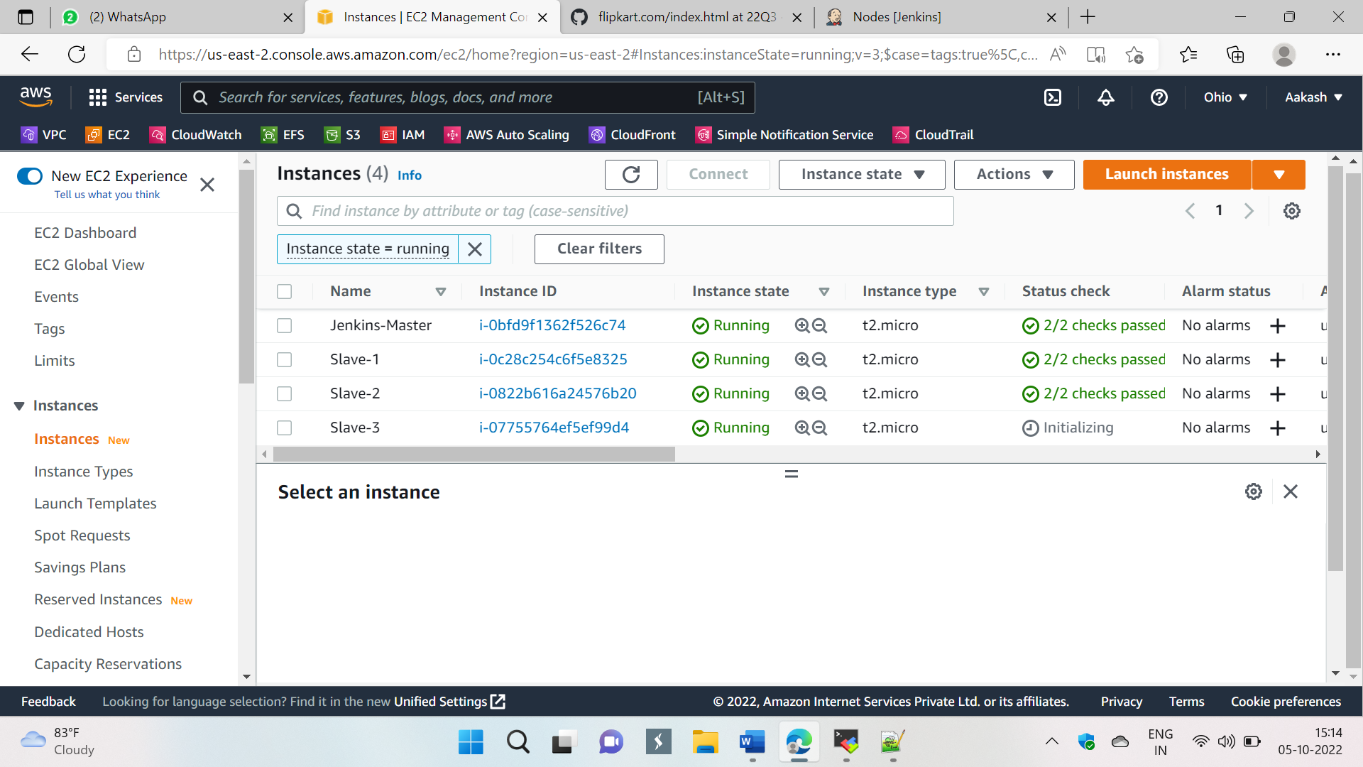

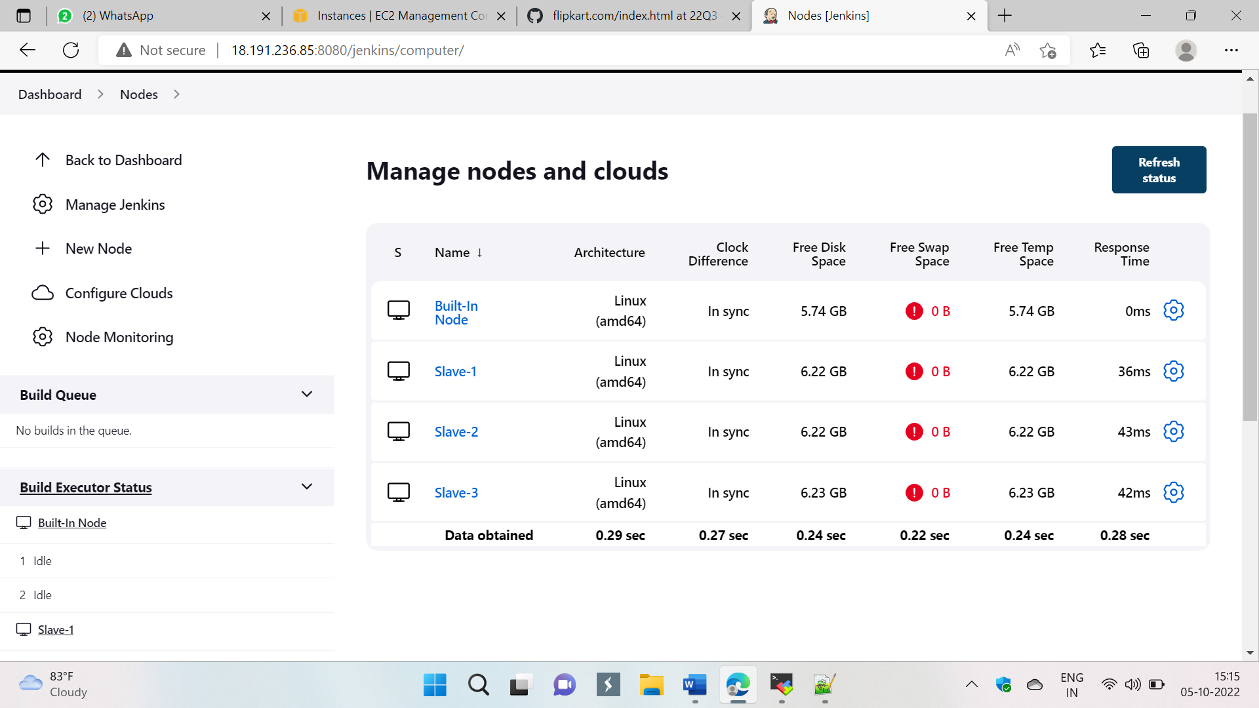

## Created Job-1

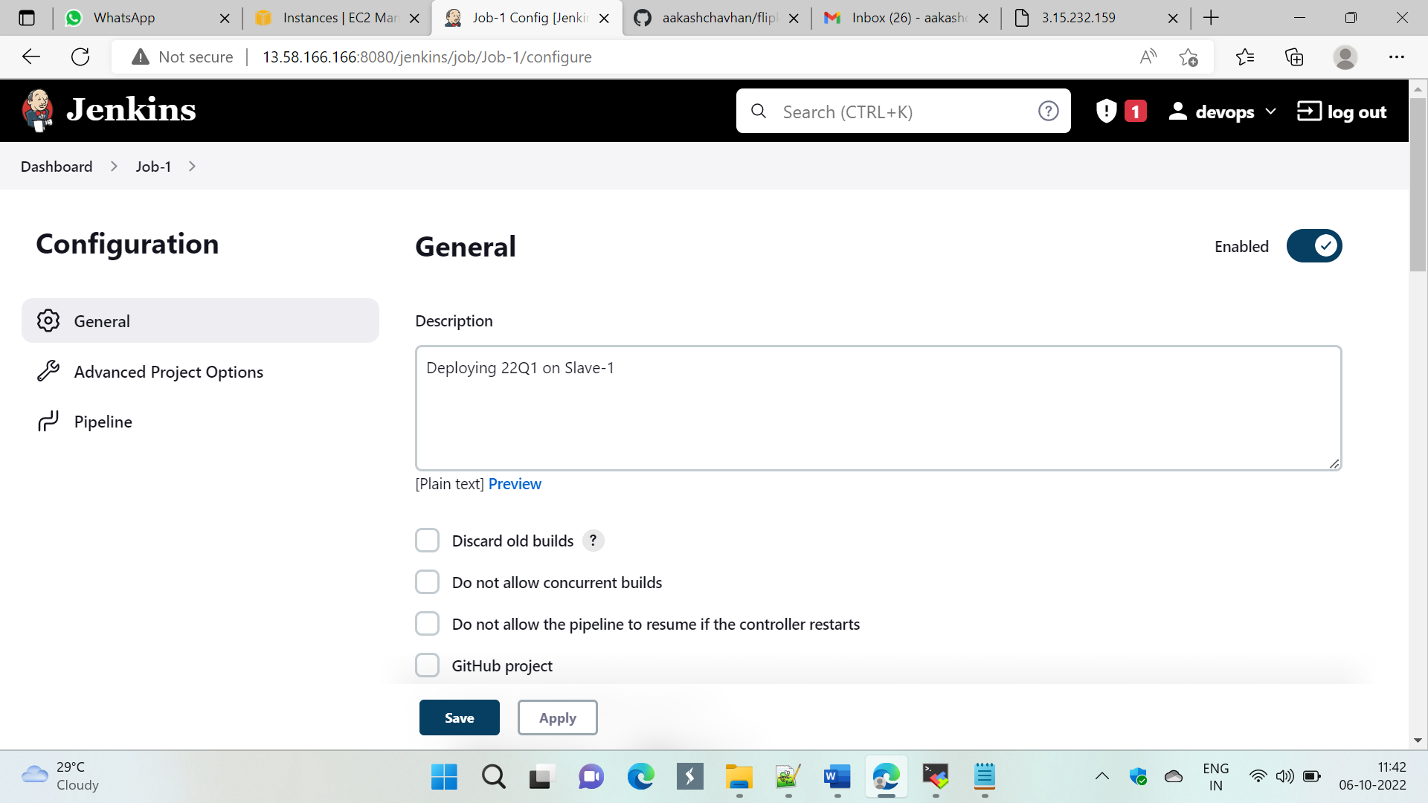

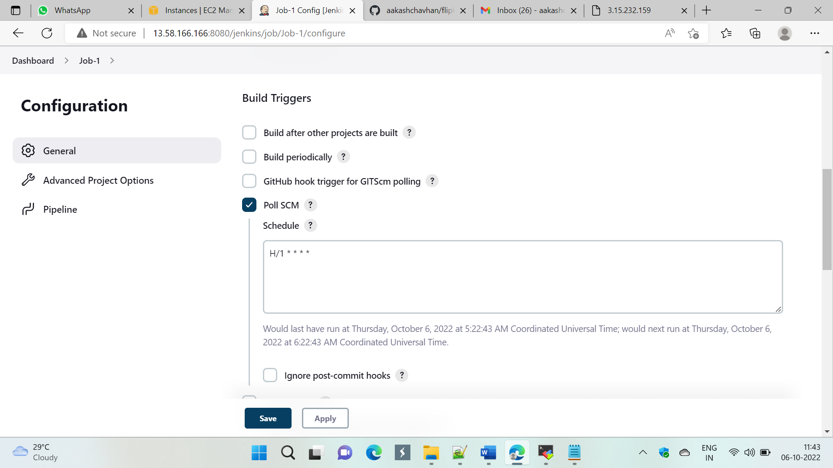

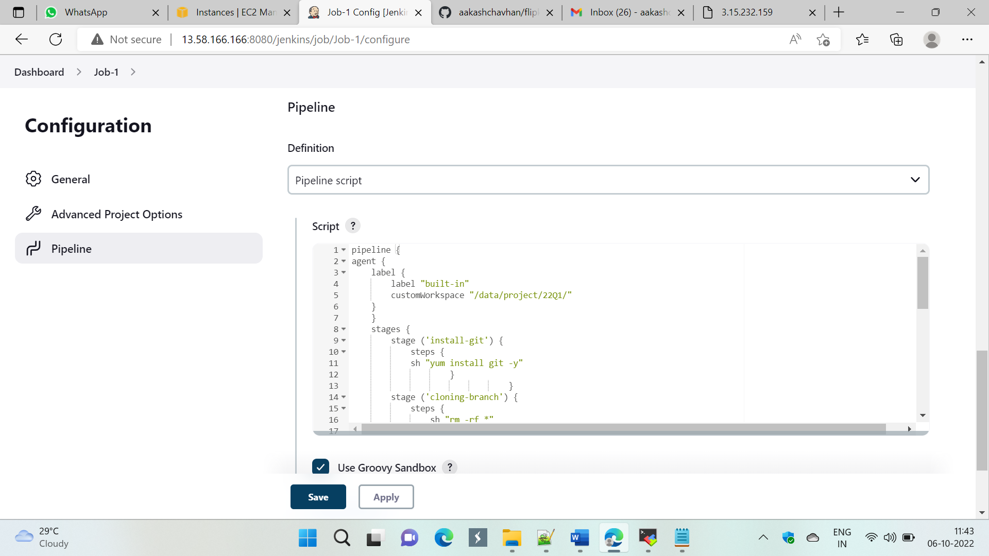

## Pipeline

pipeline {

agent {

label {

label "built-in"

customWorkspace "/data/project/22Q1/"

}

}

stages {

stage ('install-git') {

steps {

sh "yum install git -y"

}

}

stage ('cloning-branch') {

steps {

sh "rm -rf *"

sh "git clone https://github.com/aakashchavhan/flipkart.com.git -b 22Q1"

}

}

stage ('copy-index-file') {

steps {

sh "cp -r /mnt/ohio-kp.pem /data/project/22Q1/"

sh "chmod -R 777 /data/project/22Q1/flipkart.com/index.html"

sh "scp -i 'ohio-kp.pem' /data/project/22Q1/flipkart.com/index.html ec2-user@172.31.29.216:/mnt/jenkins-slave1/"

}

}

stage ('install-deploy-httpd') {

agent {

label {

label "Slave-1"

customWorkspace "/mnt/jenkins-slave1/"

}

}

steps {

sh "sudo yum install httpd -y"

sh "sudo service httpd start"

sh "sudo cp -R /mnt/jenkins-slave1/index.html /var/www/html/"

sh "sudo chmod -R 777 /var/www/html/index.html"

}

}

}

}

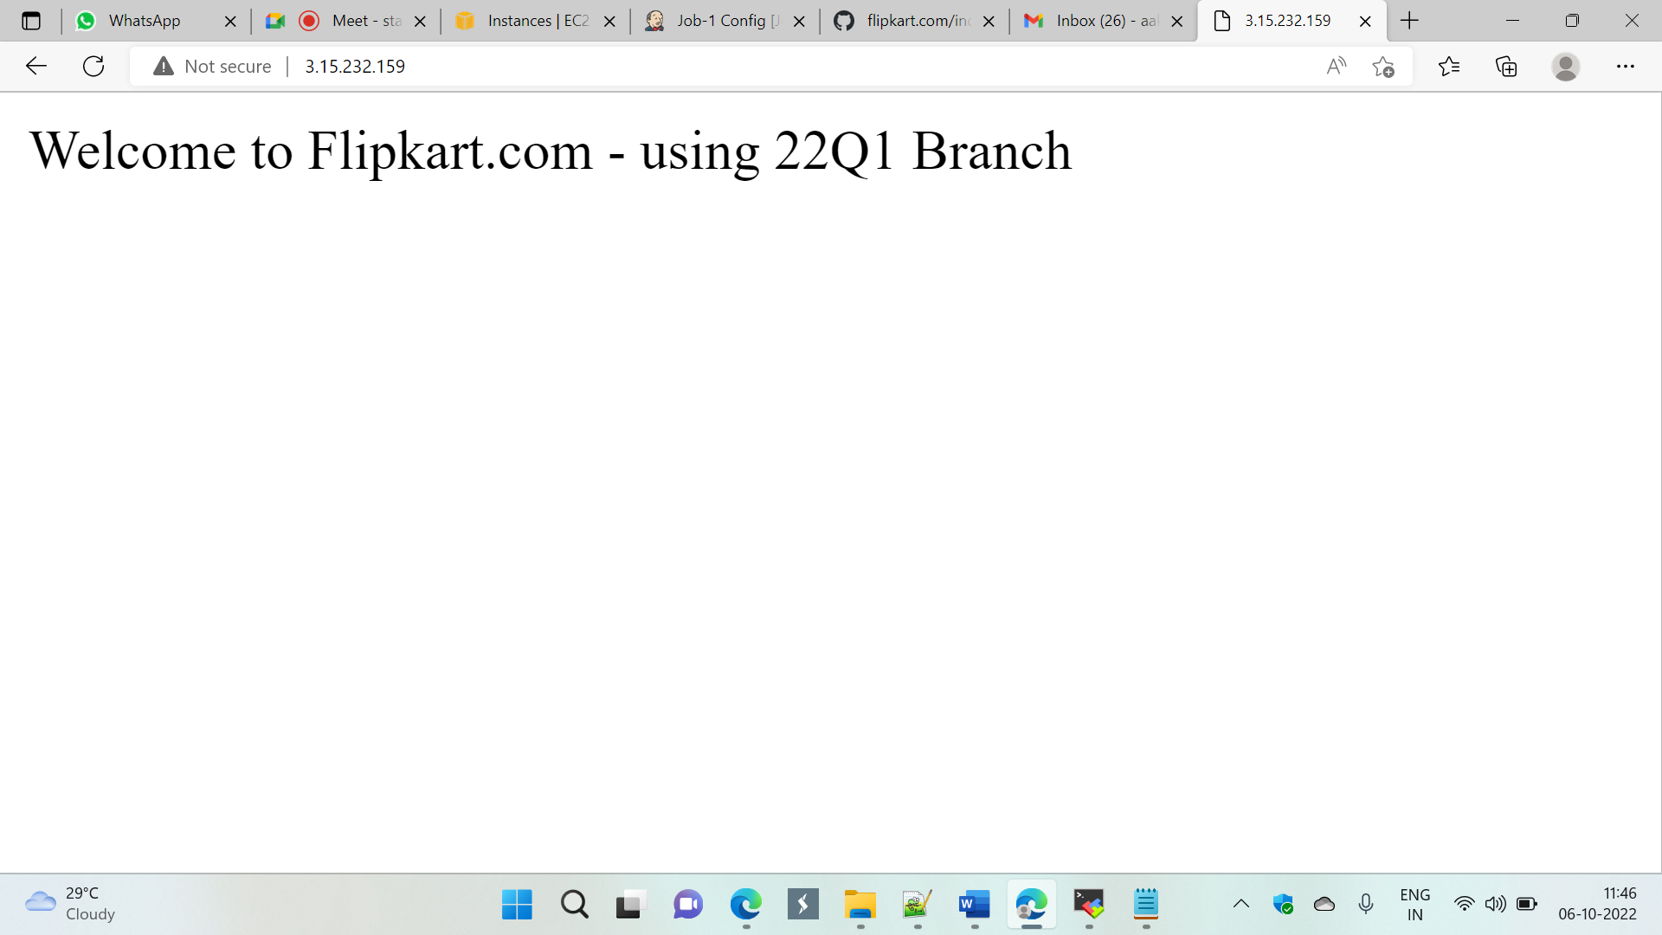

# Job-2

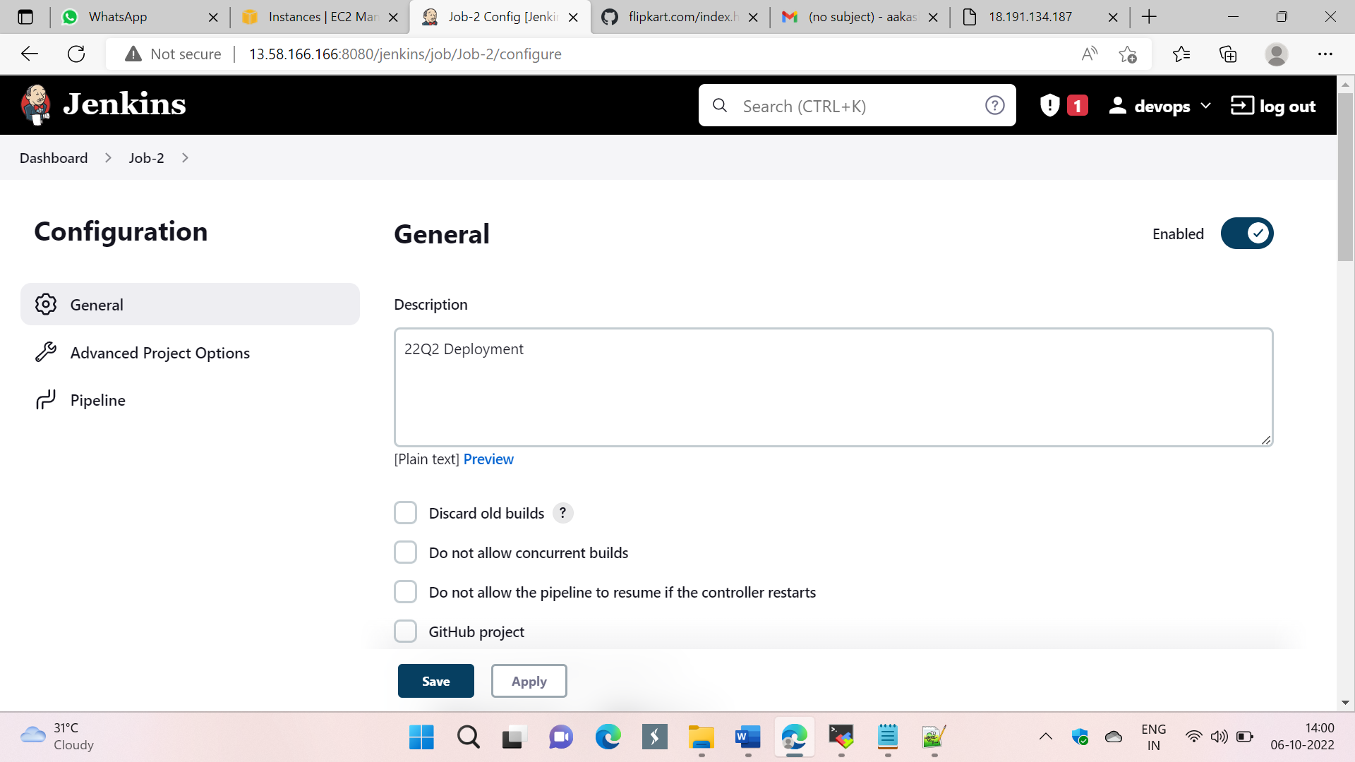

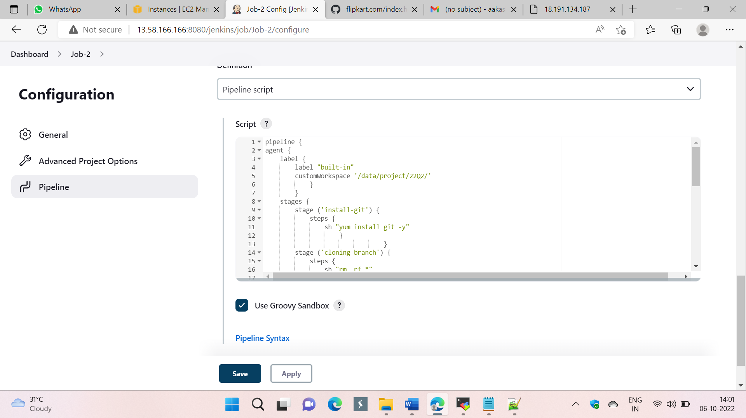

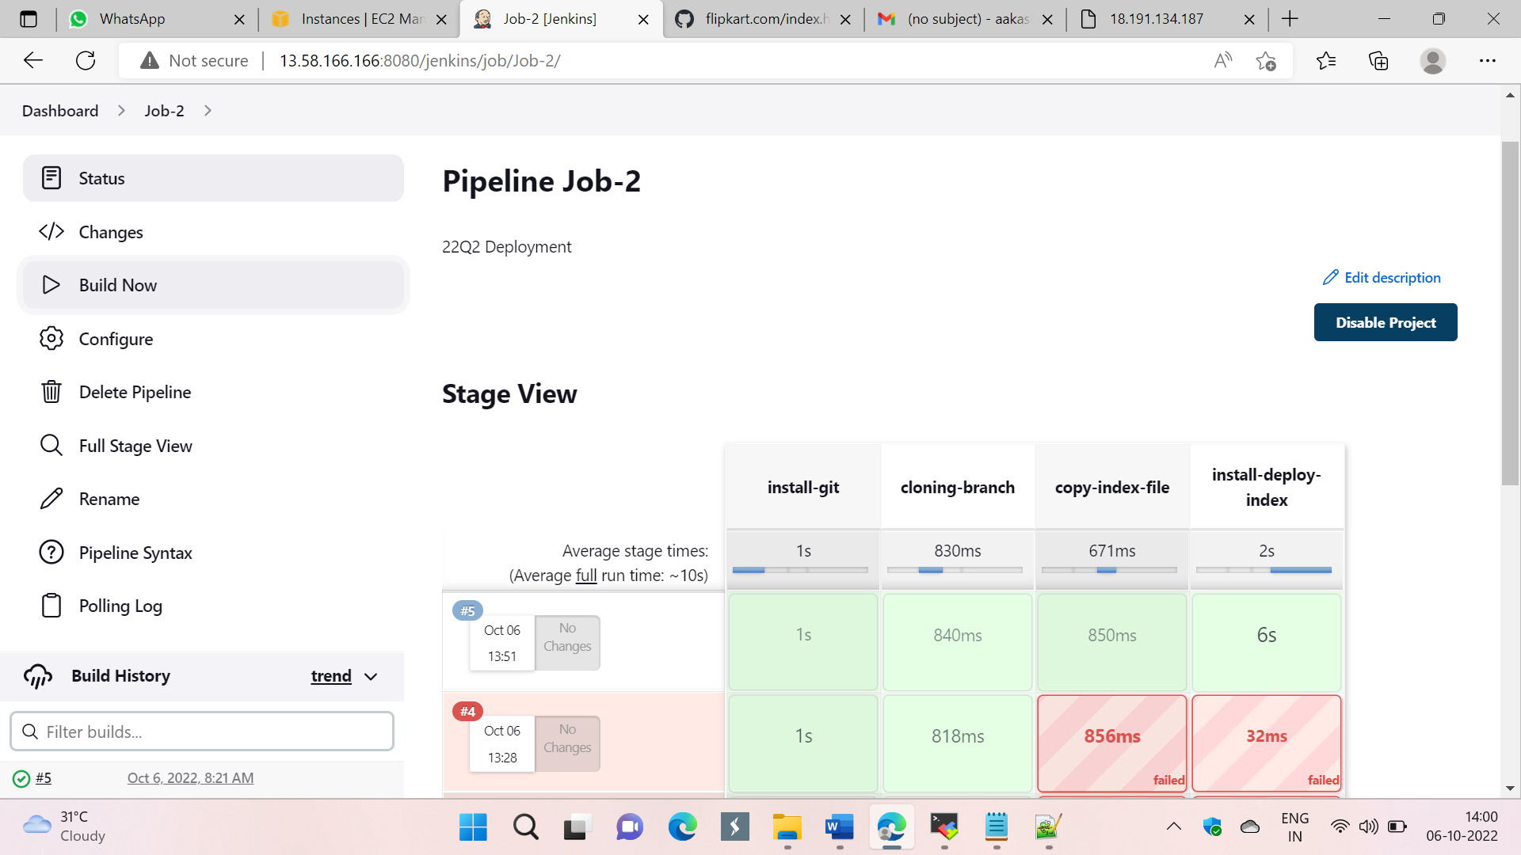

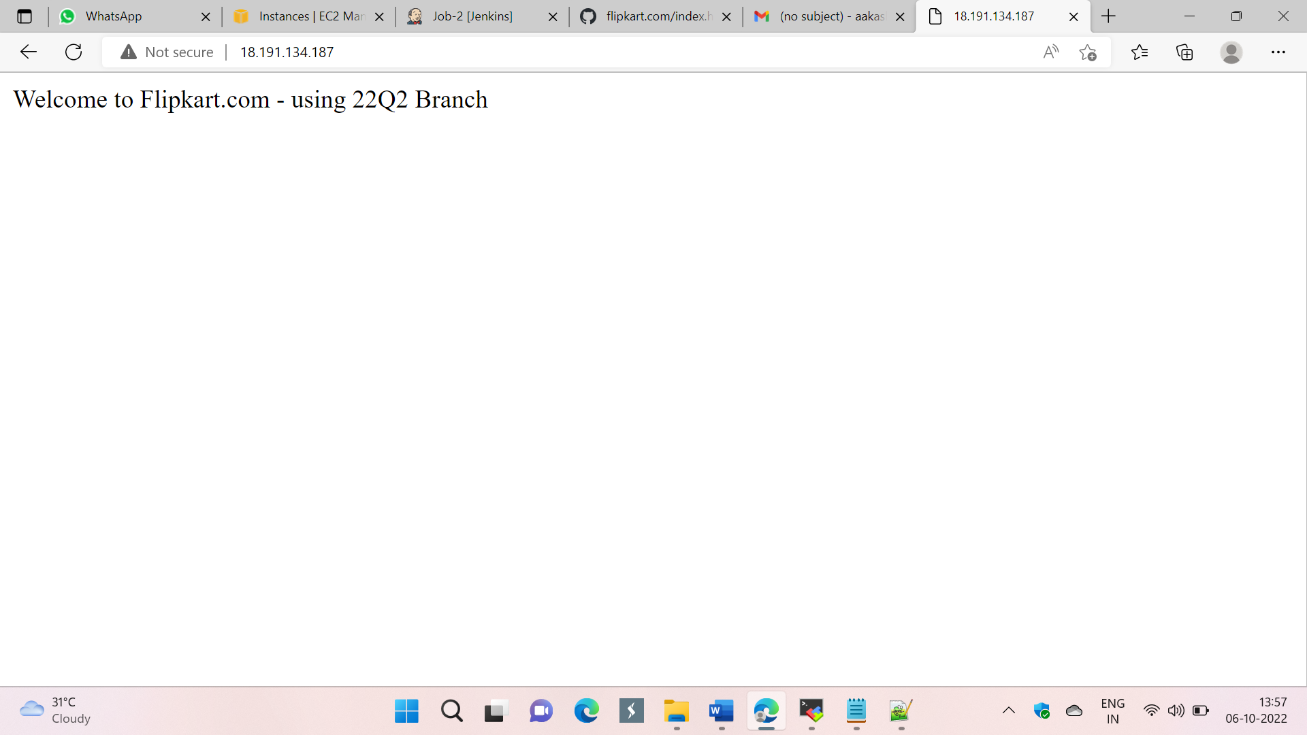

# Job – 3

pipeline {

agent {

label {

label "built-in"

customWorkspace '/data/project/22Q3/'

}

}

stages {

stage ('install-git') {

steps {

sh "yum install git -y"

}

}

stage ('git-clone') {

steps {

sh "rm -rf *"

sh "git clone https://github.com/aakashchavhan/flipkart.com.git -b 22Q3"

}

}

stage ('copy-index') {

steps {

sh "cp -r /mnt/ohio-kp.pem /data/project/22Q3/"

sh "chmod -R 777 /data/project/22Q3/flipkart.com/index.html"

sh "scp -i 'ohio-kp.pem' /data/project/22Q3/flipkart.com/index.html ec2-user@172.31.39.100:/mnt/jenkins-slave3/"

}

}

stage ('install-deploy-index') {

agent {

label {

label "Slave-3"

customWorkspace '/mnt/jenkins-slave3/'

}

}

steps {

sh "sudo yum install httpd -y"

sh "sudo service httpd start"

sh "sudo cp -r /mnt/jenkins-slave3/index.html /var/www/html/"

sh "sudo chmod -R 777 /var/www/html/index.html"

}

}

}

}

